Software Requirements Specification
For
Project-3- LEGACY HEALTHCARE REGISTRATION PAGE
Version 1.0 Draft
Prepared by RAPHAEL AMANPENE
LEGACY HEALTHCARE REGISTRATION PAGE
10/01/2024
Table of Contents
Table of Contents ii
Revision History ii
1. Introduction 1
1.1 Purpose 1
1.2 Intended Audience and Reading Suggestions 1
1.3 Project Scope 1
1.4 References 1
2. Overall Description 2
2.1 Product Perspective 2
2.2 Product Features 2
2.3 User Classes and Characteristics 3
2.4 Operating Environment 3
2.5 User Documentation 3
2.5.1 Explanation of yahoo mail to the user: 3
2.6 Assumptions and Dependencies 3
2.6.1 Website Mail.yahoo.com is registered and functional 3
2.6.2 User Account is already created at the time of log in 3
3. Yahoo! Mail Login Features 4
4. External Interface Requirements 8
4.1 User Interfaces 8
4.2 Hardware Interfaces 8
4.3 Software Interfaces 9
4.4 Communications Interfaces 9
5. Other Nonfunctional Requirements 9
5.1 Performance Requirements 9
5.2 Safety Requirements 10
5.3 Security Requirements 10
5.4 Software Quality Attributes 10
6. Other Requirements 10
Appendix B: Flow Chart 1 11
Flow Chart 2 12
Appendix C: Issues List 13

Revision History
Name | Date | Reason For Changes | Version
Raphael Amanpene | 10/01/24 | Draft Version | 1.0

Introduction

Purpose
LEGACY Healthcare Registration Page is an online portal which allows new users to create an account, submit necessary credentials, and verify qualifications securely. The system offers a user-friendly interface, guiding applicants step-by-step through the registration process.

The purpose of this document is to introduce a web-based healthcare registration page and its functionality to its users. The functionality of ABC Healthcare registration page ensures data protection and compliance with regulatory standards, making it easy for users to securely access ABC Healthcare’s services and manage their healthcare needs efficiently.

Apart from Internet Explorer, the web page should also be able to support multiple browsers and enhance user experience.

Overall Description

Operating Environment
The system should support the following operating systems:
- Windows 10, Windows 11 and above
- Mac OS (Latest stable versions)
- Linux

It must also be able to run on the following browsers:
- Google Chrome 129
- Firefox 131.0
- Microsoft Edge 128.0
- Safari 18.0

User Documentation
A step-by-step user-manual will be available online that will provide information to the user on how to sign-in and sign-out of their account. Accessible by the following link,

http://help.yahoo.com/tutorials/mmail/mmail/mm_access2.html

Explanation of Legacy Registration Page to the user:
ABC Registration Page is Web-based healthcare portal. This means that:
2.2.2 This registration page allows you to create an account and manage your healthcare needs.
2.2.3 You can book a doctor’s appointment from anywhere in the world as long as you have internet connection and successfully logging in.
2.2.4 You can also receive Lab work results and prescriptions through this secure portal.

Assumptions and Dependencies

Website ABChealthcare.com is registered and functional

User Account is already created at the time of log in

Functional Requirements
SL No | Priority | Details
REQ  1 | High | Input:  - Create a ‘Last Name’ label as displayed below.  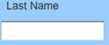  Rules:  - The words ‘Last Name’ should be displayed in gray color inside text box.  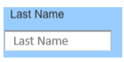
REQ  2 | High | Input:  2.1 The user inputs a valid last name in the ‘Last Name’ text box.  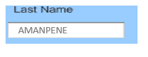  Rules:  2.2 The system should allow the user to enter a minimum of 2 and a maximum of 20 characters in this field.  2.3 The system should allow the user to enter alphabets and apostrophe.  2.4 This is a required field.  2.5 When the user places cursor inside the ‘Last Name’ text box, the system should highlight the text box’s Boarder in a Red Color  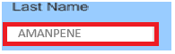  2.6 When the user starts to type in the text box ‘Last Name’, the system should make the ‘Last Name’ displayed in gray color disappear.  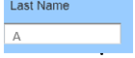  2.7 When the user clears/erases all that is typed in the text box the ‘Last Name’, the system should make the ‘Last Name’ displayed in gray color reappear
REQ  3 | High | The Validation is triggered by either of the below actions:  3.1 When user clicks the ‘Submit’ button  or  3.2 When the user presses the ‘Tab’ button.  or  3.3 When the user clicks anywhere on the screen.  or  3.4 When user presses the “Enter Key”.  
REQ  4 | High | Result of validation:  Normal Flow [If valid values are entered]  The system moves the cursor to the NPA field.  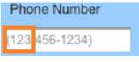  Exception Flow [If invalid values are entered]  The system should display ‘Invalid Value’ or error message.  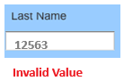
REQ  5 | High | Input: Create a ‘Phone Number’ displayed  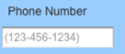  Rules:  - The ‘Phone Number’ should contain the first 3 digits which is the NPA (Area Code) of the 10-digit ‘Phone Number’  - The ‘Phone Number’ should contain the Nxx which is the 3 digits that form the second part of the 10-digit ‘Phone Number’  - The ‘Phone Number’ should contain the final 4 digits which is the subscriber number.
REQ  6 | High | NPA  6.1 The system must ensure that the NPA (area code) is always a 3-digit number  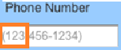  Rules  6.2 The first digit of the NPA must be between 2 and 9  6.3 The second and third digits must be between 0 and 9  6.4 The input should be numeric, except for the optional hyphen in ZIP+4codes  6.5 The length must be either 5 digits (for standard ZIP Codes) or 10 characters (for ZIP+4, including the hyphen)  6.6 This is a Required field  6.7 When the user enters a toll-free area code for NPA, the system should reject the toll free  Numbers such as 800, 833, 844, 855, 966, 877 and 888 with an invalid value message.  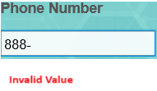  6.8 When the user enters special NPA numbers such as the numbers displayed below, the system must reject it with an invalid value message.  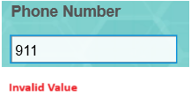  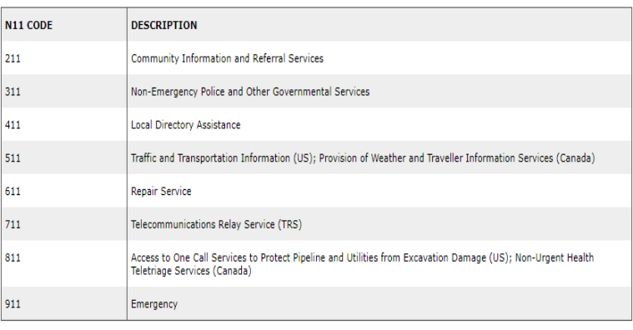
REQ  7 | High | Nxx  7.1 The system must ensure that the Nxx is always a 3-digit number  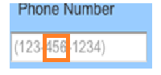  7.2 The system must verify whether the entered Nxx is active and valid.  7.2.1 The system should cross-check the Nxx with the database of active central office codes, maintained by telecom authorities.  7.2.2 Invalid or unassigned Nxx should trigger an error message  7.3 The first digit of the NPA must be between 2 and 9  7.4 The second and third digits must be between 0 and 9  7.6 This is a Required Field  7.7 When the user enters 000, the system should reject it as an invalid valid since it is not a legitimate central office code.  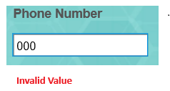
REQ  8 | High | Line  8.1 The system must ensure that the subscriber number is always a 4-digit numeric value  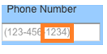  8.2 The system should only allow valid subscriber numbers within the range of 0000 to 9999  8.3 This is a Required Field
REQ  9 | High | Validation Keys  9.1 When user clicks the ‘Submit’ button  or  9.2 When the user presses the ‘Tab’ button.  or  9.3 When the user clicks anywhere on the screen.  or  9.4 When user presses the “Enter Key”.
Req 10 |  | Result of validation:  Normal Flow [If valid values are entered]  The system moves the cursor to the Email field.  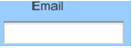  Exception Flow [If invalid values are entered]  The system should display ‘Invalid Value’ or error message.  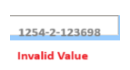
Req 11 |  | Email  11.1 Create an ‘Email’ Label as displayed below
Req 12 |  | 12.1 The system should only accept an email in the following format entered by the user: <username>, <@>, <domain>, <.>, <Top level domain name>.  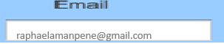  12.2 The ‘Email’ is a required field  12.3 The system should allow the user to enter up to 300 characters in this field.  12.4 The system should allow the user to enter uppercase and lowercase for the username  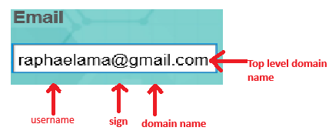  12.5 The system should only allow the user to use the ‘@’ character otherwise the system should reject any other character as an invalid value.  12.6 The system should allow the user to enter valid domain names such as yahoo, gmail etc.) as displayed above.  12.7 The system should allow the user to enter the ‘.’ character as displayed above and the system should reject other characters as an invalid value.  12.8 The system should allow the user to enter the top-level domain as “com” any other values will be invalid.
Req 13 |  | The Validation is triggered by either of the below actions:  13.1 When user clicks the ‘Submit’ button  or  13.2 When the user presses the ‘Tab’ button.  or  13.3 When the user clicks anywhere on the screen.  or  13.4 When user presses the “Enter Key”.  
Req 14 |  | Input:  14.1 When the user types the ‘Email’ in the right format <username>, <@>, <domain>, <.>, <com>, the system should validate the ‘Email’.  Result of validation:  Normal Flow [If valid values are entered]  14.2 The system should move the cursor to the ‘Address’ field.  Exception Flow [If invalid values are entered]  14.3 The system should display ‘Invalid Value’ error message.  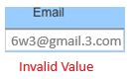
Req 15 |  | Zip  15.1 Create a ‘Zip’ Label as displayed below  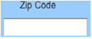
Req 16 |  | 16.1 The system should accept ‘Zip Code’ that has 5 digits  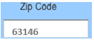  16.2 The system should accept Zip Code + 4 format.  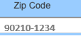  16.2.1 The first part must be a valid 5-digit Zip Code  16.2.2 The second part after the hyphen must consist of exactly 4-digits  16.2.3 The hyphen is mandatory between the 5-digit and 4-digit segments  16.3 The system should accept Numeric digits Only  16.4 The system should auto-fill the state or province if the ZIP code uniquely identifies a region.  16.5 The ‘Zip Code’ field is required.
Req 17 |  | The Validation is triggered by either of the below actions:  17.1 When user clicks the ‘Submit’ button  or  17.2 When the user presses the ‘Tab’ button.  or  17.3 When the user clicks anywhere on the screen.  or  17.4 When user presses the “Enter Key”.
Req 18 |  | Input: 18.1 When the user enters the 5 digits of the ‘Zip Code’, the system should validate the ‘Zip Code’.  Result of validation:  Normal Flow [If valid values are entered]  18.2 The system should move the cursor to the ‘Insurance Company Name’ field.  Exception Flow [If invalid values are entered]  18.3 The system should display ‘Invalid Value’ error message.  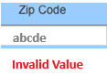

Data Definition Section:

  - Alpha
N – Numeric
SP – Special Characters
AN – Alphanumeric (Any combination of Alpha, Number and Special Characters)

Field Name | Type | Length | Type of Input | Required/Not | Font
Yahoo! ID: (Title) | AN | 10 | N/A | N/A | Blk/10/Arial
Yahoo! ID (Value) | AN | 32 | Text Box | R | Blk/10/Arial
Password (Title) | AN | 8 | N/A | N/A | Blk/10/Arial
Password  (Value) | AN | 6 Min – 32 Max | Text Box | R | Blk/10/Arial
Sign In | AN | 7 | Push Button | N/A | Blk/10/Arial

External Interface Requirements

User Interfaces
The Yahoo! User Interface has to be a set of utilities and controls, written in JavaScript, for building richly interactive web applications using techniques such as DOM scripting, DHTML and AJAX. All the controls should be easily viewable and accessible to the user. Yahoo’s color theme and its yahoo logo should be present in the GUI.

Hardware Interfaces
Information not available

Other Nonfunctional Requirements

Performance Requirements
To be decided

Safety Requirements
To be decided

Security Requirements
Yahoo! Mail should include a top-notch protection plan to help keep the user safe online. It should fight against spam, viruses, phishing, and more. There should be a constantly evolving security plan that will always be one step ahead of intruders.

Software Quality Attributes
To be decided

Other Requirements
To be decided
Appendix B: Flow Chart 1
Appendix C: Issues List

- Performance Requirements need to be addressed
- Safety Requirements need to be addressed
- Software attributes need to be addressed
- Flow chart needs to be replaced by an updated one.

Mock-up screen:

